Your School Name

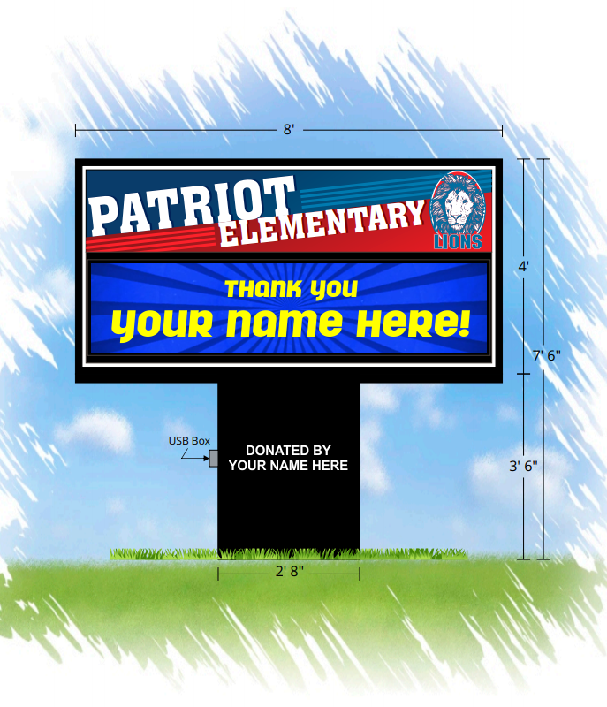
We are offering a unique opportunity that will benefit both your business and our school. Thousands of people that we would like
to communicate with pass our location regularly. For that reason,
we want to place an electronic LED sign on our campus. Opening
that vital line of communication with parents and the community
will better allow our students the opportunity to succeed.
We are planning to purchase an LED sign from Stewart Signs, America's Premier Sign Company for $**,***. We are requesting a donation of $*,*** towards our new sign. In return, we will run a personalized 'Thank You' to your business 30 times a day for six months. Your business name and logo will be seen by thousands, showing your support for our students, their parents, and the community.
Alternately, if you would like to donate the entire amount, a permanent dedication would be placed on the sign. By including it on this landmark, your business name would be a fixture of the community for years to come.

Please look at the plan for our new sign and consider your donation both an investment in your business and the success of our students.

